**Group Members:**

1. **Jany Muong** – SCT211-0848/2018

2. **Joram Kireki** – SCT211-0079/2022

3. **Gatmach Yuol Nyuon** – SCT211-0504/2021

4. **Josphat Waweru Thumi** – SCT211-0003/2022

5. **Akech Atem** – SCT211-0535/2022

6. **Vincent Ohanga** – SCT211-0070/2022

**Software Rejuvenation: A comprehensive Overview**

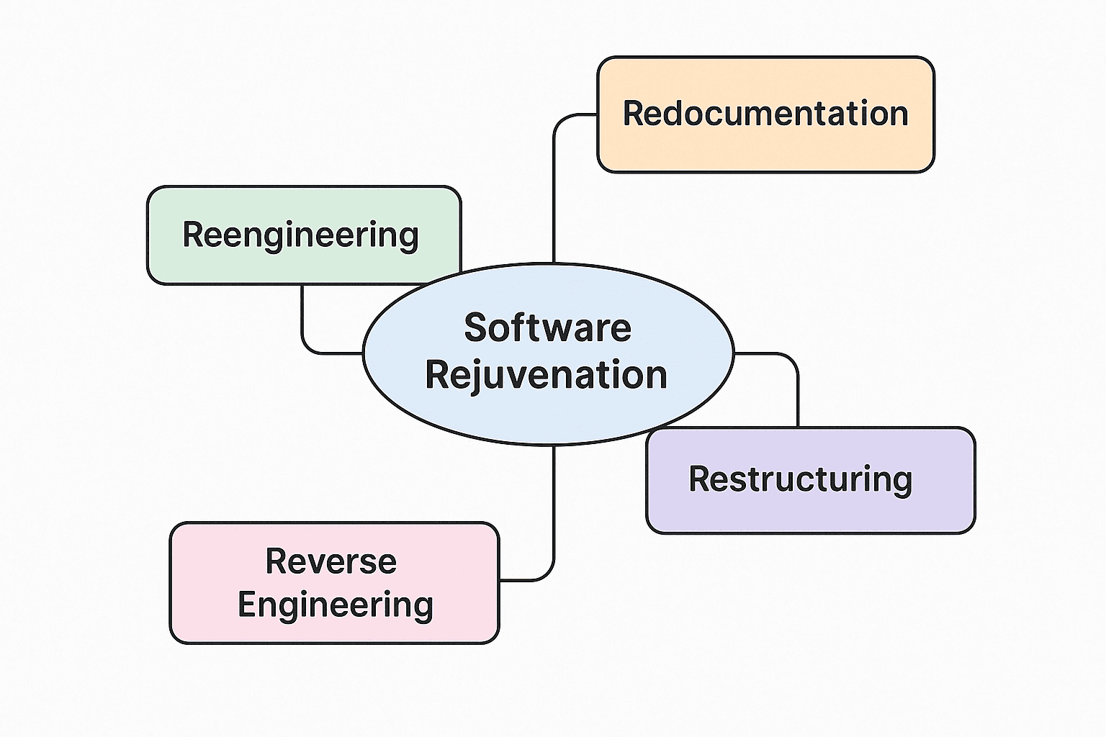

### **Introduction**

Software rejuvenation encompasses a set of proactive maintenance strategies aimed at improving the longevity, reliability, and maintainability of software systems. As software systems age, they can suffer from performance degradation, increased fault rates, and reduced maintainability. Rejuvenation techniques address these issues by restoring the software to a more optimal state without necessarily altering its external behavior.

### **Types of Software Rejuvenation**

The primary types of software rejuvenation include:

1. **Redocumentation**
2. **Restructuring**
3. **Reverse Engineering**
4. **Re-engineering**

Each of these methods serves distinct purposes in the software maintenance lifecycle.

### **1. Redocumentation**

**Definition:** Redocumentation involves creating or updating documentation to reflect the current state of the software system without modifying its source code.

**Purpose:** To enhance understanding of the software, especially when original documentation is outdated or missing.

**Activities Involved:**

* Analyzing source code to extract information about components, control flows, and data structures.
* Generating artifacts such as call graphs, data flow diagrams, and interface descriptions.

**Benefits:**

* Facilitates easier maintenance and onboarding of new developers.
* Serves as a foundation for other rejuvenation activities like reverse engineering.

**Example:**  
 A legacy billing system written in COBOL has **no documentation**. A developer reverse-engineers the logic and creates:

* Flowcharts
* Data dictionaries
* Module summaries  
   ➡ This helps onboard new developers and reduces errors during maintenance.

### **2. Restructuring**

**Definition:** Restructuring refers to modifying the internal structure of the software to improve its quality attributes without changing its external behavior.

**Purpose:** To enhance code readability, reduce complexity, and improve maintainability.

**Activities Involved:**

* Refactoring code to eliminate redundancies and improve modularity.
* Applying design patterns to standardize solutions to common problems.

**Benefits:**

* Reduces technical debt.
* Simplifies future enhancements and debugging efforts.

**Example:**  
 A Java system uses thousands of lines of procedural-style code. Developers:

* Refactor repeated code into reusable functions
* Replace nested conditionals with switch cases
* Improve variable naming  
   ➡ The system works the same but is now easier to maintain and less error-prone.

### **3. Reverse Engineering**

**Definition:** Reverse engineering is the process of analyzing a software system to identify its components and their interrelationships, often to recreate higher-level abstractions or documentation.

**Purpose:** To recover lost information, understand legacy systems, or analyze software for which source code is unavailable.

**Activities Involved:**

* Examining binaries or source code to extract design and specification information.
* Creating models such as structure charts, entity-relationship diagrams, and data flow diagrams.

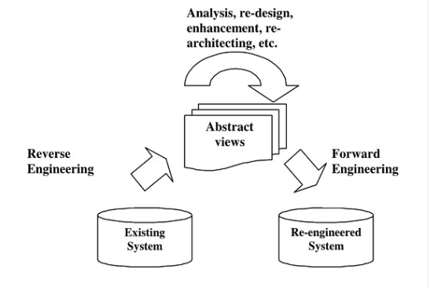

**Benefits:**

* Aids in system comprehension and documentation.
* Supports migration and integration efforts.

**Example:**  
 An organization inherits an old C++ application with **no source code access**. They:

* Decompile the binary
* Create UML diagrams to understand class structures
* Recreate API behavior docs  
   ➡ This enables the team to integrate new features or migrate to newer platforms.

### **4. Re-engineering**

**Definition:** Re-engineering involves analyzing and modifying existing software to improve its functionality, performance, or maintainability, potentially transforming it into a new form.

**Purpose:** To adapt software to new requirements or technologies while preserving its core functionalities.

**Activities Involved:**

* Assessing the current system to identify areas for improvement.
* Redesigning and reimplementing components using modern technologies or architectures.

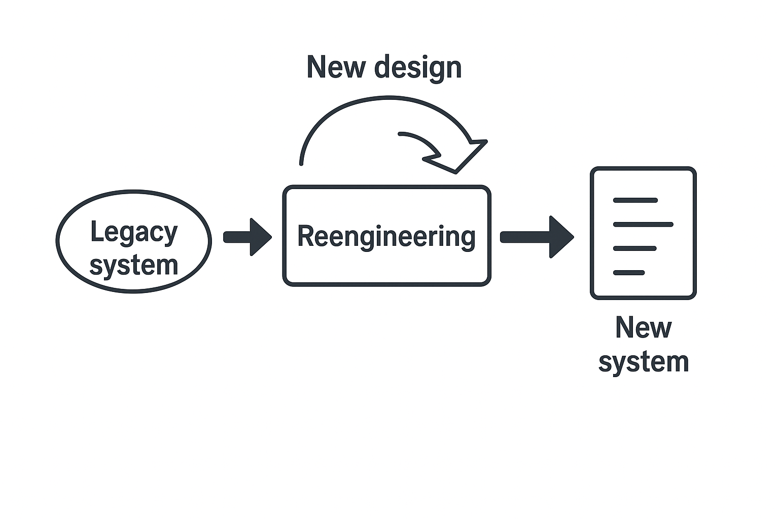

**Benefits:**

* Extends the useful life of software systems.
* Aligns legacy systems with current business needs and technological standards.

**Example:**  
 A monolithic inventory management system is too rigid. Developers:

* Split it into microservices (authentication, stock, reporting)
* Use modern tools like Docker, Kubernetes, and REST APIs  
   ➡ Performance improves, and it's easier to scale and integrate with third-party systems.

### **Conclusion**

Software rejuvenation is a critical aspect of software maintenance, ensuring that systems remain functional, efficient, and adaptable over time. By employing techniques such as redocumentation, restructuring, reverse engineering, and re-engineering, organizations can effectively manage the evolution of their software assets, reduce maintenance costs, and mitigate risks associated with software aging.